NAME: VENKATRAMAMOORTHY.G
1. Button Click Event (onclick)
CODE:
<h1>Button event</h1>
<button onclick="click1()">click me</button>
<script>
function click1(){
alert("button click event");
}
</script>
OUTPUT:
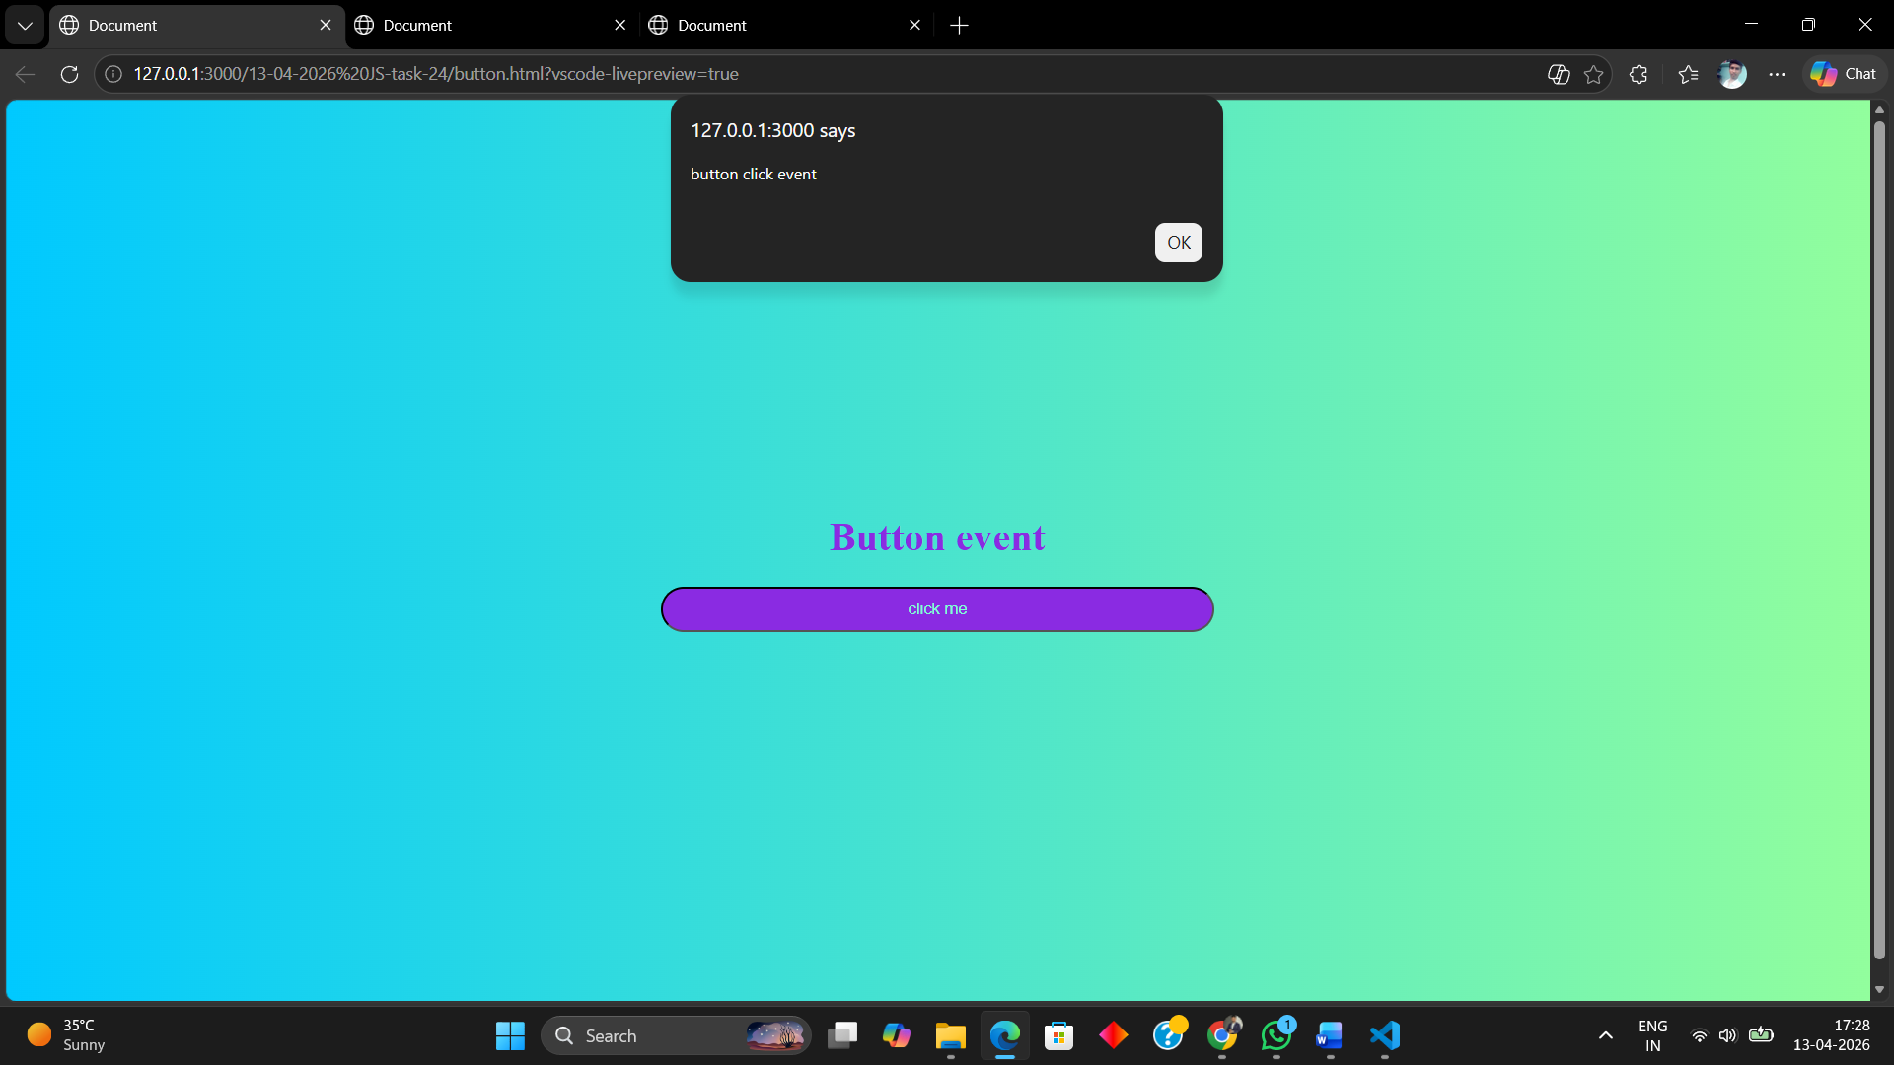
2. Show Input Value While Typing (oninput)
CODE:
<div>
<h1>when you type input it refelect below</h1>
<input type="text" id="input1">
<h2 id="output"></h2>
</div>
<script>
let input=document.getElementById('input1');
let output=document.getElementById('output');
output.style.color="blueviolet"
input.addEventListener('input',()=>{
output.textContent=input.value;
})
</script>
OUTPUT:
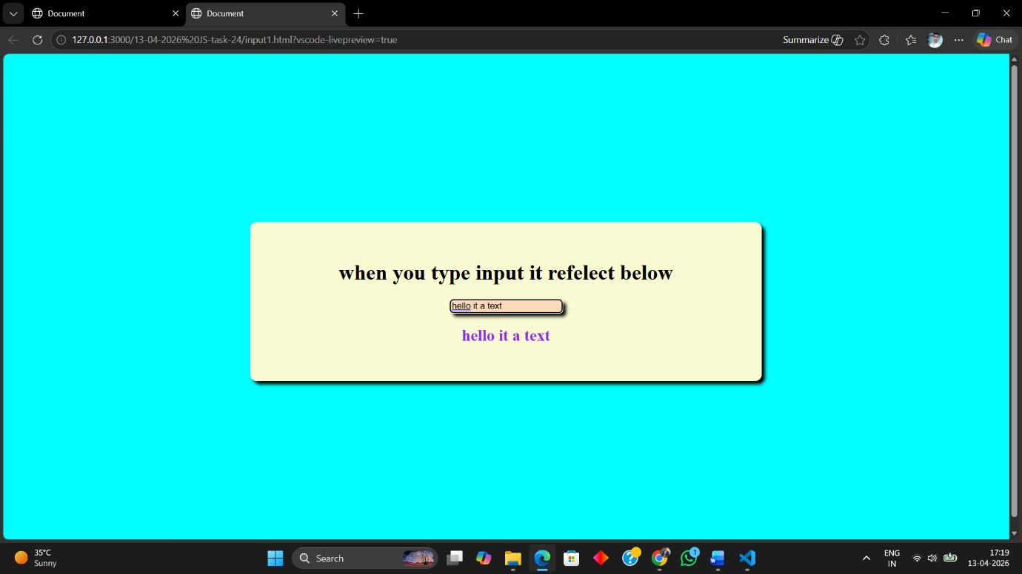
3. Add Event Listener to a Button
CODE:
<h1>Use event listener</h1>
<button onclick="click1()">click me</button>
<script>
function click1(){
alert("button click event");
}
</script>
OUTPUT:
